2.13 Postman with Jenkins



This section will guide you to understand:

* How to configure Postman with Jenkins
* How to run postman file from Jenkins

**Development Environment**

* Postman Tool
* Endpoint URL
* Jenkins

This guide has four subsections, namely:

2.13.1 Installing Jenkins

2.13.2 Exporting Collection to desktop

2.13.3 Building that postman file in Jenkins

2.13.4 Pushing the code to GitHub repositories

**Steps 2.13.1:** Installing Jenkins

* Jenkins is already installed in your practice lab in /usr/share/jenkins directory. Refer to QA to QE lab guide -- Phase 2 for more information.
* Open cmd goto jenkins.war location and run a command:

Java -jar jenkins.war (you need to install Java before running this command)

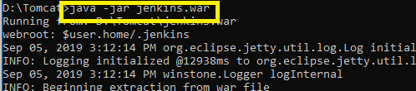

* Then open localhost:8080 on browser

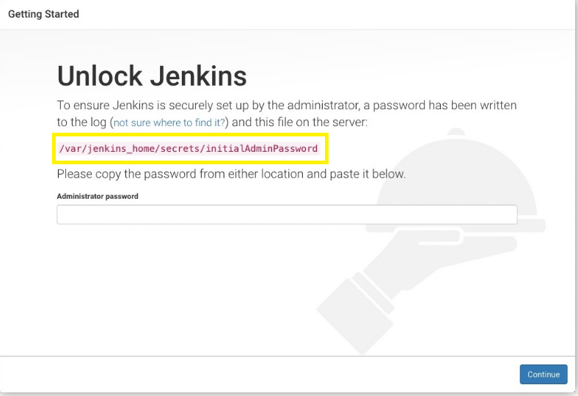

* Go back to the terminal and use the following command to find the Admin Password:

*sudo cat /var/lib/jenkins/secrets/initialAdminPassword*

* Type the password in the browser
* You will get a proper Jenkins window after setting up your admin password

**Steps 2.13.2:** Exporting Collection to desktop

* Open Postman
* Create a Collection
* Export the Collection

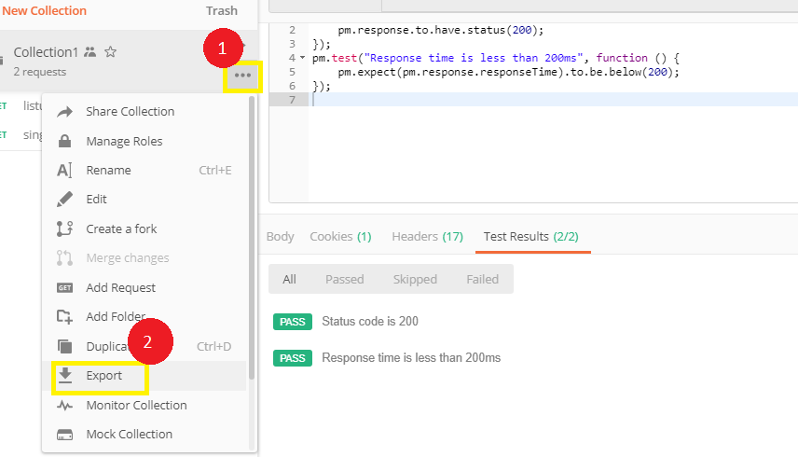

* Always choose Collection V2.1 (recommended)
* Save it on your desired location

**Steps 2.13.3:** Building that postman file in Jenkins

* Open Jenkins
* Create a job with the name Newman

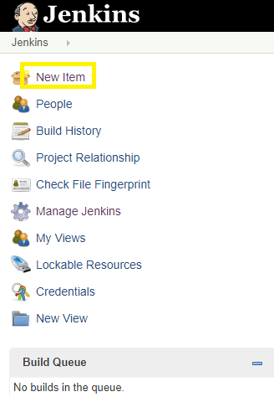

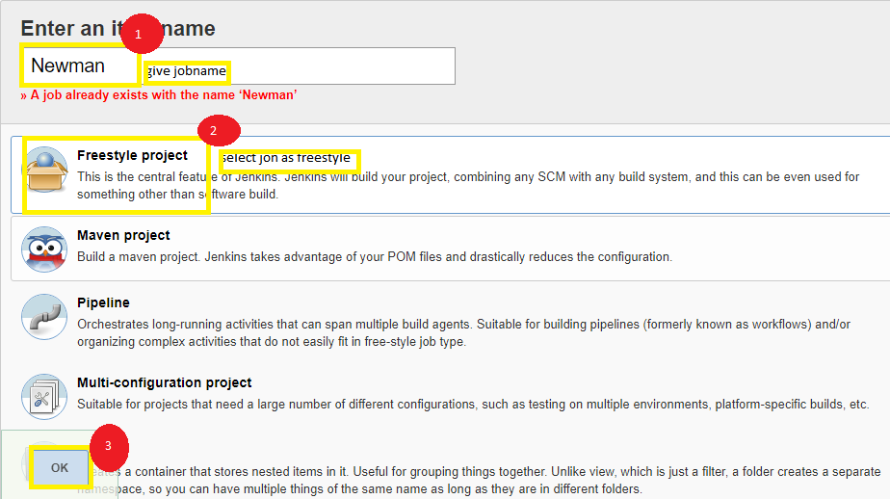

* Pass two commands in your Execute windows batch command

cd C:\Users\Prakat-L-004\Desktop\Postman

newman run Collection1.json

* Apply
* Save

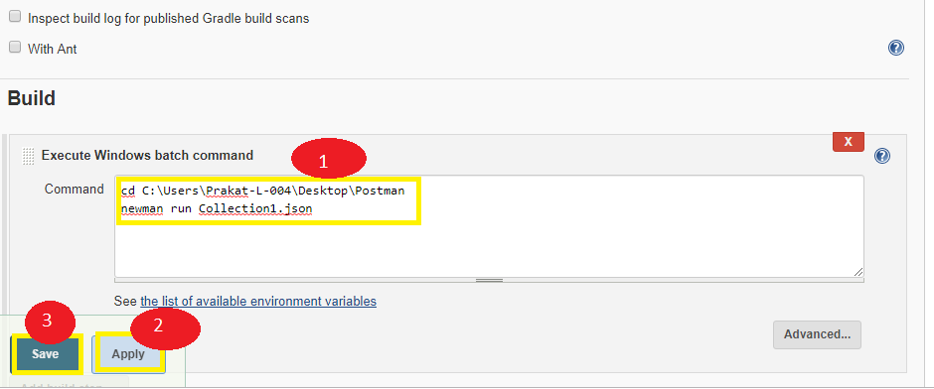

* Go to build

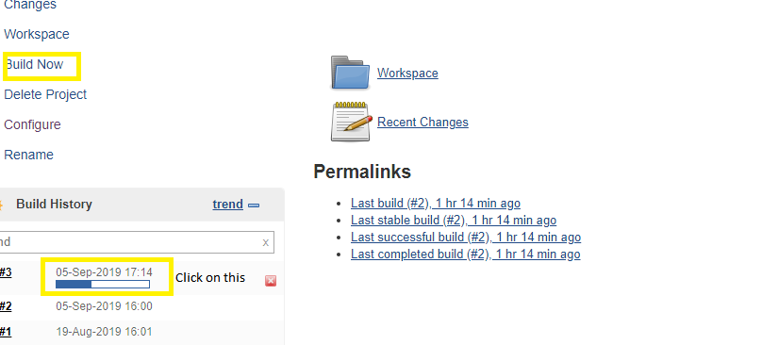

* Click on the build tab
* Go to console
* [View as plain text](http://localhost:8080/job/NewMan/3/consoleText)
* Output: Finished Success

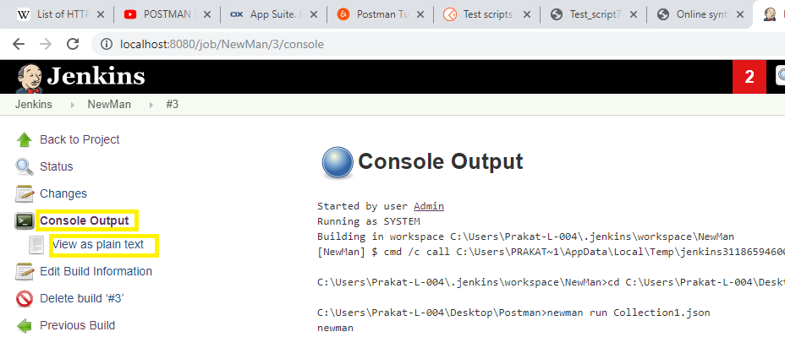

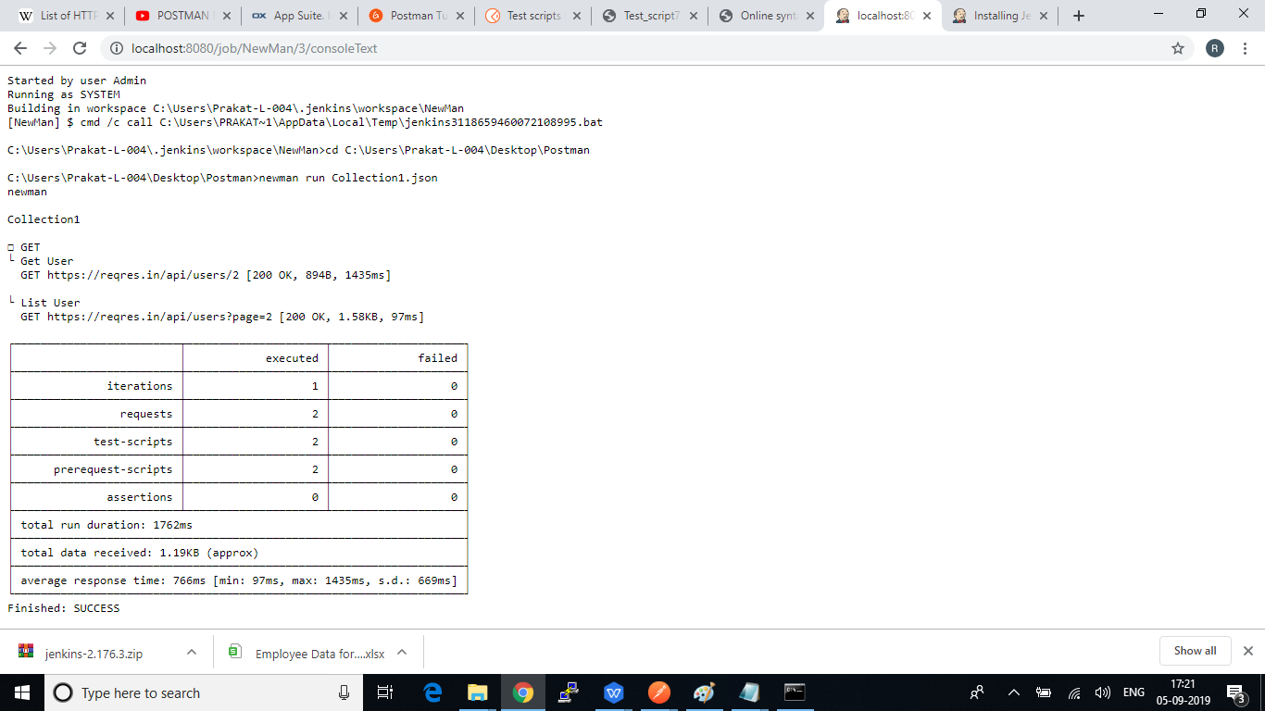

**Steps 2.13.4:** Pushing the code to GitHub repositories

Open your command prompt and navigate to the folder where you have created your files

cd <folder path>

Initialize your repository using the following command:

git init

Add all the files to your git repository using the following command:

git add . 

Commit the changes using the following command:

git commit . -m “Changes have been committed.”

Push the files to the folder you initially created using the following command:

git push -u origin master